**Pre Track Inspection location is on the Northern side of the Mentor Garage.**

**Hours:**

Friday 5PM-6PM

Saturday (Later of) Gate Access or 6:30 AM-7:25AM

One-off inspections: After these times, as available

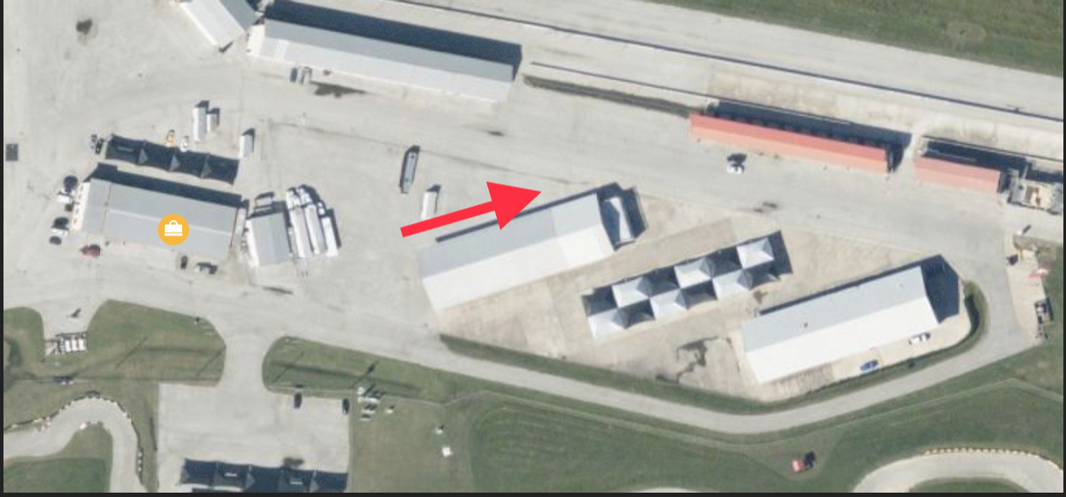

* Current Helmet Certification
* Extraneous items removed from vehicle
* Harnesses are current, and if present, a HANS device must be used
* Cameras and data loggers are tethered
* Gas caps and tow-hooks are in place

Inspection occurs once for the weekend. Vehicles will not be allowed on track without a windshield sticker.